**ME-338: Manufacturing Processes II**

Project Report

**Temperature Simulation in**

**LASER Cladding Process**

**By**

|  |  |
| --- | --- |
| DARSHIL DESAI | 160020018 |
| MANOJ PARMAR | 150100021 |
| MRUNMAYI MUNGEKAR | 160020012 |
| TANYA GUPTA | 150040010 |

**Under the Guidance of**

Prof. R.K. Singh

Department of Mechanical Engineering

INDIAN INSTITUTE OF TECHNOLOGY BOMBAY

2018

**INDEX:**

1. Abstract
2. Introduction of the problem undertaken in the project
3. Literature review of existing work done in that area
4. Brief description of process modelling
5. Results and Discussion
6. Potential outcomes of project
7. Open issues for further investigation

ABSTRACT

**Calculation for the Heat Affected Zone:**

Approximation: The fused or the Heat Affected Zone (HAZ) is assumed to be circular in nature. Width and height of both the clad bead and fused zone has been measured using co-ordinate option provided in Ansys fluent result section.

Readings are noted down in excel

Sample Calculation

Power supplied: 1000 W

Height of clad bead: 1.2 mm

Width of clad bead: 1.2 mm

Height of HAZ formed: 1.893 mm

Width of HAZ formed: 2.578 mm

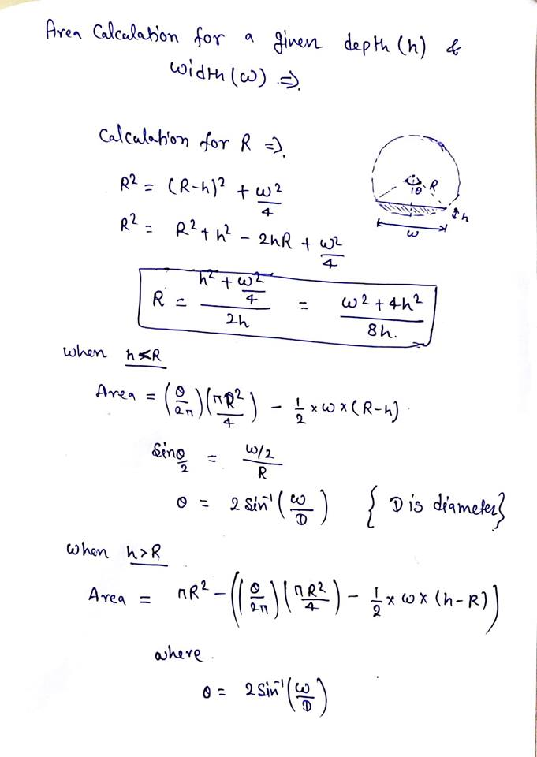

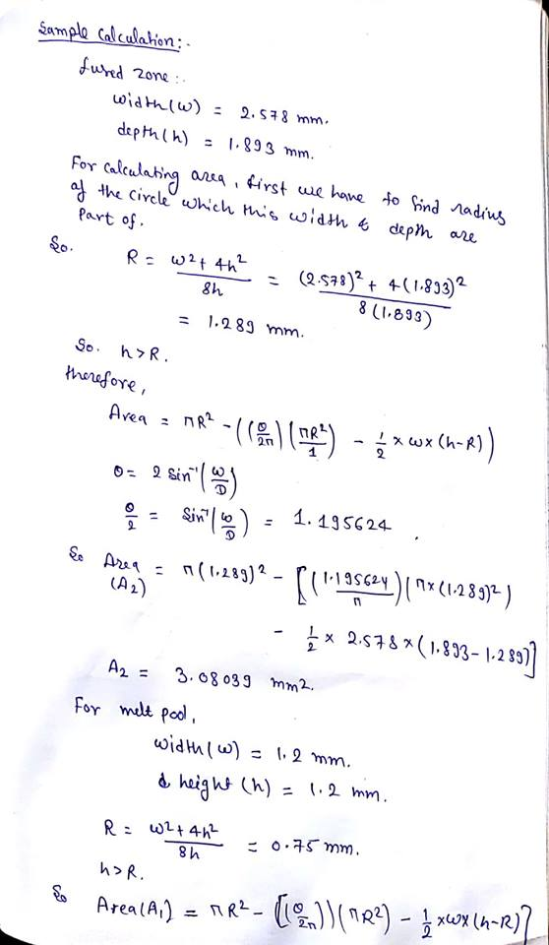

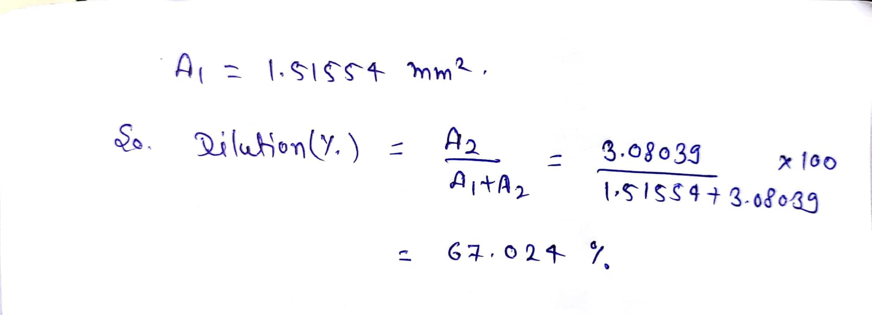For HAZ

Radius of HAZ formed, R2: 1.289 mm

Area of HAZ, A2: 3.08039 mm^2

For clad bead

Radius of clad bead, R1: 0.75 mm

Area of clad bead, A1: 1.51554 mm^2

Dilution, D

$dilution, D=\frac{A2}{A2+A1}=67.024$

Data points has been collected from simulation for four different clad bead heights, h and different laser power inputs, P which has been listed

i) Clad bead of height, h = 0.8 mm and width 1.2 mm

|  |  |  |  |
| --- | --- | --- | --- |
| power(W) | width of HAZ w(mm) | depth of HAZ h(mm) | Radius of clad deposited(mm) |
| 1000 | 1.3368 | 0.4506 | 0.625 |
| 600 | 1.208 | 0.0727 | 0.625 |

ii) Clad bead of height, h = 1 mm and width 1.2 mm

|  |  |  |  |
| --- | --- | --- | --- |
| power(W) | width of HAZ w(mm) | depth of HAZ h(mm) | Radius of clad deposited(mm) |
| 1000 | 1.8655 | 1.00379 | 0.68 |
| 600 | 1.48126 | 0.56594 | 0.68 |
| 400 | 1.25206 | 0.24927 | 0.68 |
| 350 | 1.22638 | 0.14664 | 0.68 |

iii) Clad bead of height, h = 1.2 mm and width 1.2 mm

|  |  |  |  |
| --- | --- | --- | --- |
| power(W) | width of HAZ w(mm) | depth of HAZ h(mm) | Radius of clad deposited(mm) |
| 1000 | 2.578 | 1.893 | 0.75 |
| 700 | 2.2436 | 1.4943 | 0.75 |
| 500 | 1.9338 | 1.1021 | 0.75 |
| 400 | 1.7402 | 0.93503 | 0.75 |
| 200 | 1.25768 | 0.2893 | 0.75 |

iv) Clad bead of height, h = 1.5 mm and width 1.2 mm

|  |  |  |  |
| --- | --- | --- | --- |
| power(W) | width of HAZ w(mm) | depth of HAZ h(mm) | Radius of clad deposited(mm) |
| 500 | 2.86198 | 1.62152 | 0.87 |
| 200 | 1.60274 | 0.63671 | 0.87 |
| 150 | 1.318 | 0.3274 | 0.87 |

Calculations have been done using Excel and relevant graphs have been plotted

Graph: Width of HAZ vs Laser Power

Graph: Minimum power vs Height of HAZ

Graph: Dilution percentage vs Laser power